**Recipe Finder Screenshots**

**Main Page**

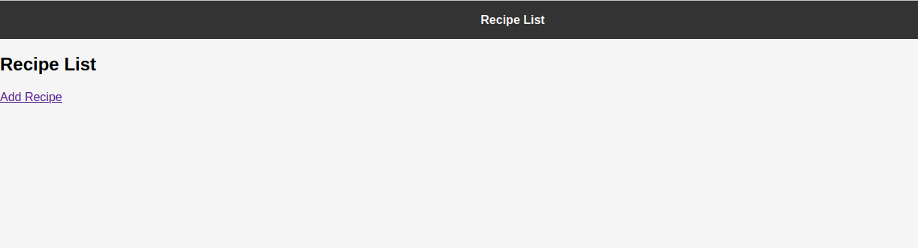

**Add Recipe**

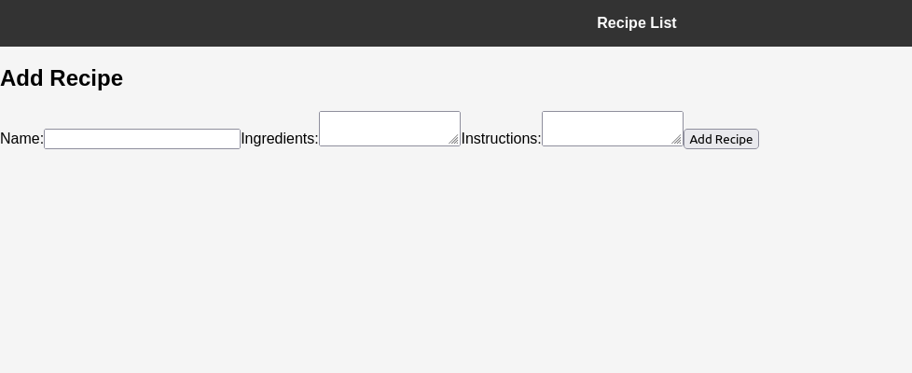

**Input Date**

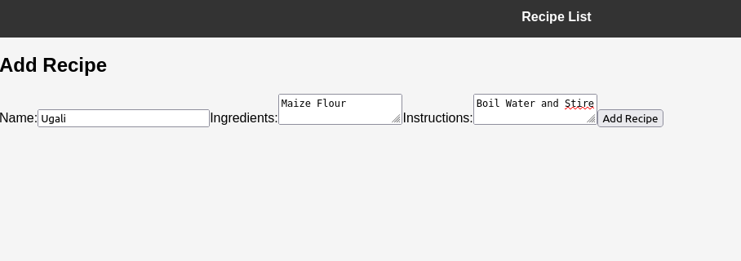

**View Added Recipe**

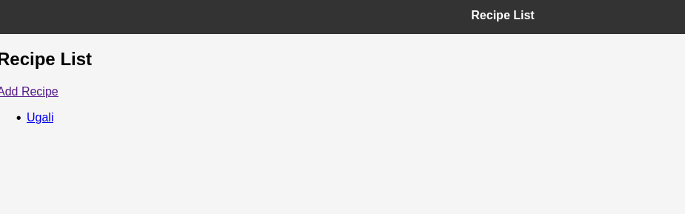

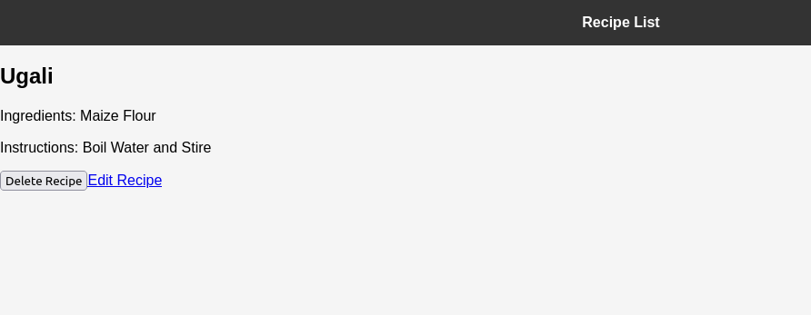

**Edit Recipe**

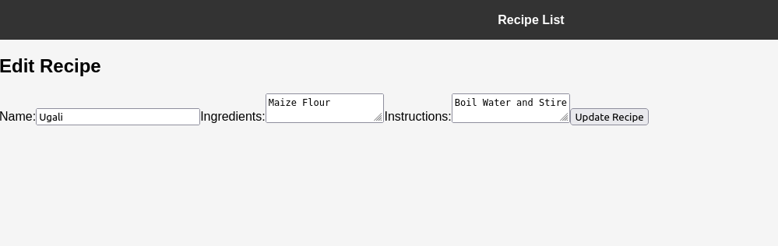

**Delete Recipe**

